PART A
(Part A: TO BE REFERRED BY STUDENTS)
Experiment No. 09-B
A.1 AIM:
To normalize the given relational table and the relational model.
A.2 Pre requisite:
Basic concepts of database normalization, data models like ER-models and relational model.
A.3 Outcome:
After successful completion of this experiment students will be able to

- Convert the ER diagram into equivalent relational model.
- Learn to design a good relational model using normalization.
- Application of normalization and types of normalization.

A.4 Theory:

Normalization
A large database defined as a single relation may result in data duplication. This repetition of data may result in:
- Making relations very large.
- It isn't easy to maintain and update data as it would involve searching many records in relation.
- Wastage and poor utilization of disk space and resources.
- The likelihood of errors and inconsistencies increases.
So to handle these problems, we should analyze and decompose the relations with redundant data into smaller, simpler, and well-structured relations that are satisfy desirable properties. Normalization is a process of decomposing the relations into relations with fewer attributes.

What is Normalization?
- Normalization is the process of organizing the data in the database.
- Normalization is used to minimize the redundancy from a relation or set of relations. It is also used to eliminate undesirable characteristics like Insertion, Update, and Deletion Anomalies.
- Normalization divides the larger table into smaller and links them using relationships.
- The normal form is used to reduce redundancy from the database table.
Why do we need Normalization?
The main reason for normalizing the relations is removing these anomalies. Failure to eliminate anomalies leads to data redundancy and can cause data integrity and other problems as the database grows. Normalization consists of a series of guidelines that helps to guide you in creating a good database structure.
Data modification anomalies can be categorized into three types:
- Insertion Anomaly: Insertion Anomaly refers to when one cannot insert a new tuple into a relationship due to lack of data.
- Deletion Anomaly: The delete anomaly refers to the situation where the deletion of data results in the unintended loss of some other important data.
- Updatation Anomaly: The update anomaly is when an update of a single data value requires multiple rows of data to be updated.

Types of Normal Forms:
Normalization works through a series of stages called Normal forms. The normal forms apply to individual relations. The relation is said to be in particular normal form if it satisfies constraints.
Following are the various types of Normal forms:
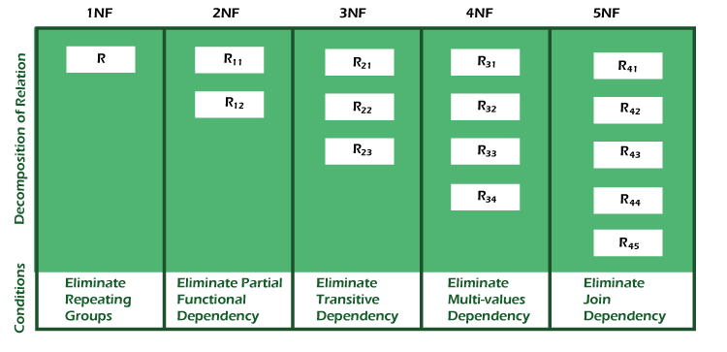
Normal Form | Description
1NF | A relation is in 1NF if it contains an atomic value.
2NF | A relation will be in 2NF if it is in 1NF and all non-key attributes are fully functional dependent on the primary key.
3NF | A relation will be in 3NF if it is in 2NF and no transition dependency exists.
BCNF | A stronger definition of 3NF is known as Boyce Codd's normal form.
4NF | A relation will be in 4NF if it is in Boyce Codd's normal form and has no multi-valued dependency.
5NF | A relation is in 5NF. If it is in 4NF and does not contain any join dependency, joining should be lossless.

Advantages of Normalization
- Normalization helps to minimize data redundancy.
- Greater overall database organization.
- Data consistency within the database.
- Much more flexible database design.
- Enforces the concept of relational integrity.

Disadvantages of Normalization
- You cannot start building the database before knowing what the user needs.
- The performance degrades when normalizing the relations to higher normal forms, i.e., 4NF, 5NF.
- It is very time-consuming and difficult to normalize relations of a higher degree.
- Careless decomposition may lead to a bad database design, leading to serious problems.

A.5 Task to be completed in PART B:
A.5.1 Task1
      - Normalize the Relational model created in previous experiment that is experiment no. 7. Also show how model is changing after each normalization level.
Hint:-
Department(d_name, d_no, d_location, manger_name, start-date, aadhar_card )
P.k(d_no) and F.k (aadhar_card)
Functional dependencies are
Aadhar-card manager_name
Manager_name start-date
Dependents (ID, aadhar_card, name, sex, birthdate, relation)
P.k(ID) and f.k(aadhar_card)
Functional dependencies are
Aadhar-card relation

No normalization needed in the following relations.
Project (p_name, p_no, p_loc)
P.k(p_no)
Employee (aadhar_card, address, salary, sex, dob)
p.k(aadhar_card)
technical-employee ( aadhar_card, weekly-no-of-hours, score, p-no)
nontechnical-employee (aadhar_card, insentive)

      - Consider the following database example and normalize it at least up to 3NF.
Assume, a video library maintains a database of movies rented out. Without any normalization in database, all information is stored in one table as shown below.
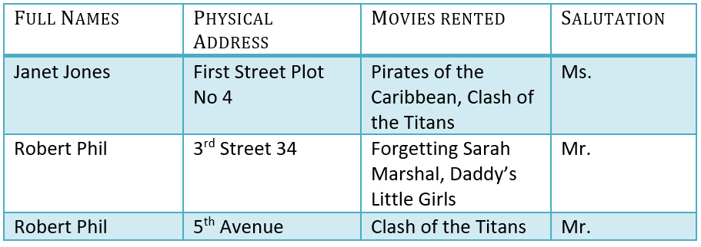
PART B
(PART B: TO BE COMPLETED BY STUDENTS)
(Students must submit the soft copy as per following segments within two hours of the practical. The soft copy must be uploaded on the Blackboard or emailed to the concerned lab in charge faculties at the end of the practical in case the there is no Black board access available)
Roll No. : C172 | Name: Parva Gaglani
Class :D | Batch :D2
Date of Experiment : | Date/Time of Submission :
Grade :

B.1 Tasks given in PART A to be completed here
(Paste your answers and output here)

    - : Normalization steps with updated relational model/ Relational Tables.

Customer(Customer_ID, Full_Name, Salutation)
Address(Address_ID, Customer_ID, Address)
Movie(Movie_ID, Movie_Name)
Rental(Customer_ID, Movie_ID)

- Cutomer table
Customer_ID | Full_Name | Salutation
C1 | Janet Jones | Ms.
C2 | Robert Phil | Mr.

- Address table
Address_ID | Customer_ID | Address
A1 | C1 | First Street Plot No 4
A2 | C2 | 3rd Street 34
A3 | C2 | 5th Avenue

- Movie table
Movie_ID | Movie_Name
M1 | Pirates of the Caribbean
M2 | Clash of the Titans
M3 | Forgetting Sarah Marshall
M4 | Daddy’s Little Girls

- Rental table

Customer_ID | Movie_ID
C1 | M1
C1 | M2
C2 | M3
C2 | M4
C2 | M2

B.2 Conclusion:
We learned how to normalize the given relational table and the relational model.

(Students must write the observations and learning based on their understanding built about the subject matter and inferences drawn)

B.3 Question of Curiosity
(To be answered by student based on the practical performed and learning/observations)

Q1. Write your observation related to difference between functional dependencies and multivalued dependencies.
Basis | Functional Dependency (FD) | Multivalued Dependency (MVD)
Meaning | One attribute determines another attribute | One attribute determines multiple independent values of another attribute
Relation | A → B | A →→ B
Dependency type | Single value dependency | Multiple values dependency
Condition | For each value of A, there is only one value of B | For each value of A, there can be multiple values of B independent of other attributes
Usage | Used in 2NF and 3NF normalization | Used in 4NF normalization
Example | Aadhar → Name | Student →→ Hobby
Redundancy | Causes partial or transitive dependency | Causes repeating groups
Goal | Reduce data redundancy | Remove multi-value repetition

Q2. What is F⁺? Given some example.

F⁺ means closure of functional dependencies.
It is the set of all functional dependencies that can be derived from given functional dependencies using rules like:
• Reflexive rule
• Augmentation rule
• Transitive rule
F⁺ helps to:
- find candidate key 🔑
- check normalization
- identify all dependencies

